**For TSCAN:**

Warning: Error in : Insufficient values in manual scale. 14 needed but only 10 provided.

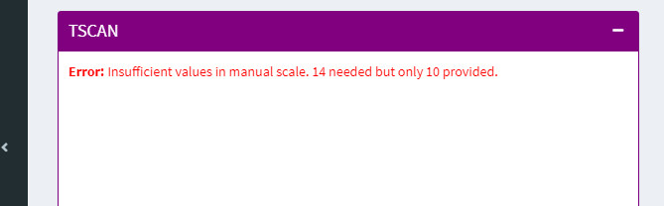

**Slingshot:**

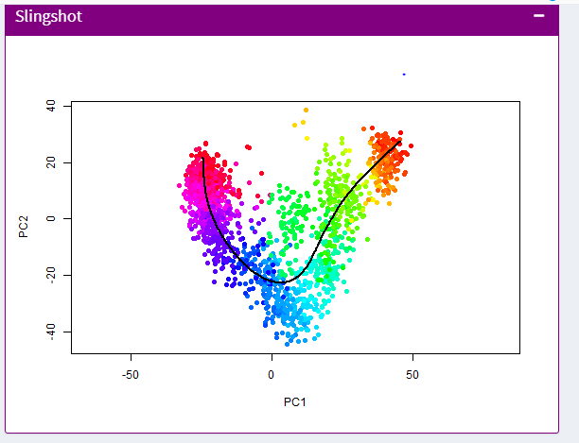

But sometimes it showed-

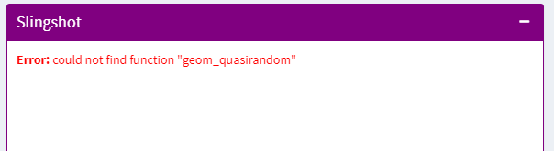

**Monocle2:**

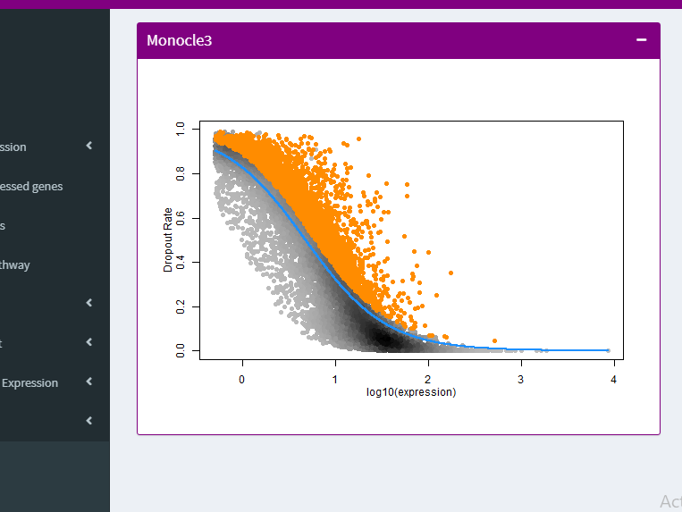

But sometimes it showed-

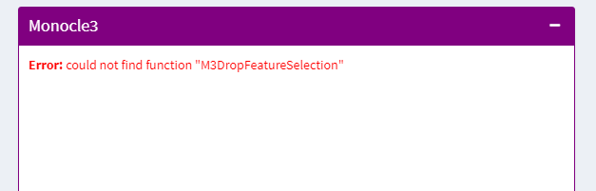

**For slicer:**Warning: not a recognized matrix class, coercing to 'matrix'.

Warning: Error in dataset_extract_doublematrix: Data needs to be matrix, data.frame, ExpressionSet, or SingleCellExperiment

